Simulation sprint recap

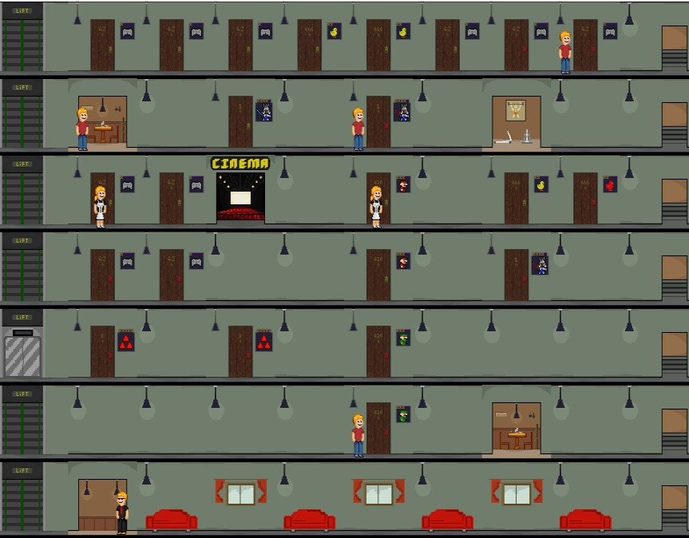

Inhoud

Summary 3

Recap sprint 1 4

Completed user stories: 4

Sprint evaluation 4

Things that went good: 4

Improve for next sprint: 4

Recap sprint 2 5

Completed user stories 5

Sprint evaluation 6

Things that went good: 6

Improve for next sprint: 6

Recap sprint 3 7

Completed User stories 7

Sprint evaluation 8

Things that went good: 8

Improve for next sprint: 8

Recap sprint 4 9

Completed user stories 9

Sprint evaluation 10

Things that went good: 10

# Summary

On September the 24th we started our project called: Hotel simulation. We decided to work in a Scrum environment and have 4 sprints of 1 week each. In order to visualize our Scrum we decided to use Trello board.

Our Trello environment can be found at:

<https://trello.com/b/viabuTYd/hotel-simulator-sprint-1>

The project team members are:

Jasper Paardekooper 17039886

Marnix Wieffering 17020379 Project leader

Teun Blaas 17136652

And we have a video of a working simulation

<https://drive.google.com/file/d/1hBxScGQbL5RBsVH0xpkjJZUh57xaOO0q/view>

Our Code frequency:

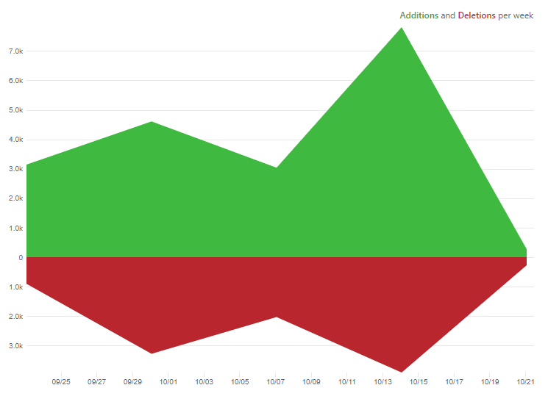

# Recap sprint 1

Because this was the first week for the project. We needed to set up an environment where we a version control for our programming results. Also we had to brainstorm about how we want to do this project. The main problem in week 1 was that we had incomplete information and different kind of product owners. So combining two visions into one was a tricky start. Also figuring out the delivered dll file was also a hard task.

## Completed user stories:

* HK-018 As PO I want the Hotel Simulation to be expandable
* HK-021 As PO I want the Json file to be serialized
* As PO I want to know what the Layout is for the hotel simulation
* As PO I want to know more about the requirements of the Hotel Simulation
* HK-014 As PO I want the images and textures for the hotel
* HK-019 AS PO I want to be able to see the history of the programmers
* HK-013 As PO I want a start screen that can click to run the main screen

## Sprint evaluation

Our sprint started on September the 24th and ended on September the 28th . We completed the task that we wanted and had no user stories left over that we had to bring to next sprint. We needed to say 3 things that went well this sprint and 3 things that we can improve for our next sprint.

## Things that went good:

* Communication
* Always on time
* good use of Trello

## Improve for next sprint:

* Get concrete information
* Understand Git commands better
* Be more on one line together

# Recap sprint 2

Our second sprint went a lot smoother than sprint 1. We just had feedback from our Product Owner on our project. The main problem in week 2 was that we had to look into Design Patterns and what we want to use and how we want to implement it.

The problem of using a Factory method was that the program is no longer Dynamic and once you received a new file you had to adjust a lot of thing. In order to solve this issue we implemented a Lazy Math method that can read out our classes and use that to create the Types. What we wanted to reach at the end of sprint 2 is that we had a modular program.

## Completed user stories

* HK-54 As PO I want a Unit Test of the start-up screen
* Hk-055 As PO I want Unit Tests for the simulation
* HK-056 As PO I want the Area factory tested
* HK-004 AS PO I want the hotel rooms have a max capacity for specific area's
* HK-045 I want guests to be able to find their way in the hotel
* HK-017 As PO I want to have a program that will read the delivered DLL files correctly
* HK-025 As PO I want to have an overview during the simulation
* HK-030 As PO I want the lobby on the bottom side of the layout and there is nothing reserved
* HK-029 As PO I want stairs to be on the right side of the layout
* HK-028 As PO I want the elevators on the left side of the layout
* HK-002 As PO I want the Hotel rooms to be occupied by only 1 guest
* HK-041 As PO I want the rooms to be connected on the entry spot
* HK-038 As PO I want the Hotel to have an overview of facilities
* HK-042 As PO I want to have people, like guests and staff
* HK-044 As PO I want to have an overview of the people in the Hotel
* HK-007 As PO I want to have multiple kinds of facilities, with different sizes
* HK-039 As PO I want the Hotel facilities have a definition
* HK-020 As PO I want events to be read out of the delivered DLL
* HK-003 As PO I want a status implemented on rooms for example when they are full, empty, dirty or cleaned
* HK-043 As PO I want a new guest to be added to the list op people in the hotel when the guest checks in
* HK-037 As PO I want the Json file to be Modular build
* HK-005 As PO I want the facilities to be able to close, for example a restaurant
* HK-024 As PO I want to be able to change the HTE variable. For example 2 HTE in 1sec or more

## Sprint evaluation

Our sprint 2 started on October 1st and ended on October 5th. We had no open task left and we Completed our design philosophy that we had a modular program, and that we have no issues if the Product owner would like to have new implementations. We needed to say 3 things that went well this sprint and 3 things that we can improve for our next sprint.

## Things that went good:

* Communication
* Understanding the Design patterns
* Picking up impediment user stories.

## Improve for next sprint:

* Don’t push to the git master branch!
* Assign a priority list of user stories

# Recap sprint 3

Our meeting with the Product Owner has been moved earlier. In this case we had a good talk about the priority list of what we need to implement for the project.

Because we are not developing in Test Driven Development we kind of left Unit testing alone. So our main concern for this week was that we had some Unit Tests that is covering our project. Also we had a discussion about how the hotel.layout file should be read out. At the end of the day it doesn’t matter how the hotel.layout file has been read out as long as it’s working it should be fine. Also we didn’t’ have an elevator yet in the project so this week we created user stories for the elevator.

## Completed User stories

* HK-012 As PO I want an elevator that is able to change the capacity for example it can only bring 1 person to 6 customers to a floor
* HK-009 As PO I want that the simulation runs event based
* HK-035 As PO I want the maximum of HTE to be 20
* HK-008 As PO I want that the customers walk by the reception and will wait until it's their turn to get a room assigned
* HK-010 As PO I want a working reception desk that can assign a customer to a room
* HK-301 As Dev I want guest to behave dynamically
* HK-058 As Dev is want to have I Area and Dijkstra search properties decided from one another
* HK-031 As PO I want customers to enter the left bottom side of the hotel.
* Hk-65 As Dev I want the rooms to have a new image when a guest checks in
* HK-034 As PO I want a restaurant to be exactly same for all customers.
* HK-016 As PO I want to have an overview of Customers, Staff, Rooms when the simulation is running
* HK-046 there should be no non typed rooms in the hotel
* HK-006 As PO I want that when there are no rooms left, the new customer will leave
* HK-015 As PO I want to have a start screen where the user can press run
* HK-036 As PO I want the gym HTE to be random for each customer
* HK-047 As Dev I want the hotel settings to be in their own function
* HK-032 As PO I want a guest to get a upgrade if the requested room is not available. For example if he wants a 4 star room and none are available, the guest will get a 5 star room if its available. (always upgrade, never downgrade)
* HK-061 As PO I want an modular design for hotel so if there are other hotel design's the program can still use it without having errors
* HK-060 As Dev I want an overview that doesn't flicker more than 150 times per minute
* HK-302 As Dev I want JsonHotelBuilder to be refactored

## Sprint evaluation

Our third sprint started on October 8th  and ended on October 12th. We completed most of our tasks for this sprint, but we had 1 task left open and that was the elevator. It seems having our Dijkstra algorithm working with the smart Elevator gave use some issue’s. So we have the elevator user story for next week implemented. We needed to say 3 things that went well this sprint and 3 things that we can improve for our next sprint.

## Things that went good:

* Communication
* Asking and answering questions
* Team work

## Improve for next sprint:

* Get concrete information of the product owner what the requirements are
* Don’t push to the git master branch!
* Change our design philosophy

# Recap sprint 4

So because we had a user story left open. We knew where to start, implement the elevator. Our meeting with the Product Owner was changed from Thursday to Monday. Our feedback for the project was that not all events were quite implemented and that we had to focus on that.

Main issues for our last sprint was that our Deadline was not changed to October 28th as we hoped. And that in our last sprint the code would be a bit of sloppy because we have less time to refactor and rethink or redo our philosophy.

We had a few requirements for our self.

* We want to deliver a complete Hotel simulation with al working events
* We want al public methods tested where we can and aim above 70% code coverage
* We want a working simulation that doesn’t crash
* We want to have a proper documentation for the program
* We want to have a proper documentation for the sprint

## Completed user stories

* HK-408 As Dev I want a code coverage of 70
* HK-66 As PO I want to be able to pause and resume the simulation
* HK-67 As PO I want to be able to change variables during the simulation
* HK-403 As PO I want the simulation timing to be changed while the simulation is running
* HK-022 As PO I want a smart behaving elevator like real life.
* HK-001 As PO I want to have a working Hotel Simulation where the hotel Staff, customers and rooms will be simulated.
* HK 410 As Dev I want a better implementation of overview of the rooms
* HK-031 As PO I want maids to be able to use the elevators
* HK-027 As PO I want the cleaning emergency to be added to the maids que
* HK-057 As Dev I want proper clean-up after killing a simulation
* HK-401 As PO I want that the guest will handle the incoming events correctly and that each guest will get his correct event
* HK-033 As PO I want if a cinema is already started that customers can still enter and will leave at the same time when the cinema HTE ends
* HK-023 As PO I want that during an evacuation, nobody can use the elevator, Except for the people that are already in the elevator
* HK-411 As Dev I want the code to be properly commented (xml)
* HK-405 As Dev I want proper documentation for the project
* HK-68 As Dev I want bad code that is not understandable refactored or commented really well
* HK-409 As Dev I want reasonable maintainability index
* HK-402 As Dev I want a proper code clean-up

## Sprint evaluation

Our fourth sprint started on October 15th  and ended on October 20th. We completed all of our tasks for this sprint. We wasted too much time on the elevator that other task weren’t picked up on time. That is why our sprint is one day delayed. We needed to say 4 things that went well this sprint.

## Things that went good:

* Communication
* Asking and answering questions
* Code refactor
* Motivation